YUVAINTERN · EMBEDDED SYSTEMS ENGINEER INTERNSHIP

SmartSense
Battery-Powered Smart Home Environment Monitor
Week 1 Task: System Requirements Analysis and Block Diagram Design
Item | Details
Prepared by | Sowmiya S
Internship | Embedded Systems Engineer Intern (4 weeks)
Internship period | 19 October 2026 to 16 November 2026
Task | Week 1: System Requirements Analysis and Block Diagram Design
Document version | 1.0 (final submission)
Date | October 2026
Abstract
This report defines the requirements and architecture of SmartSense, a battery-powered smart home sensor node that measures temperature, relative humidity, barometric pressure, ambient light and room occupancy, and reports the data over Wi-Fi to a home MQTT broker. It contains a structured specification of 54 numbered requirements, a hardware block diagram, a layered software architecture, an operating-cycle flowchart, a component selection study with a weighted decision matrix, a power budget estimating 69 days of operation per charge at a five-minute reporting interval, a requirements traceability matrix, a risk register and a verification plan for the remaining internship weeks.

Contents
Section | Title | What it covers
1 | Introduction | Background, problem statement, objectives, scope, stakeholders, link to the 4-week plan
2 | Methodology | Approach, requirement conventions, assumptions, information sources, work breakdown
3 | System Requirements Analysis | Use cases, functional, performance, I/O, interface, power, real-time and non-functional requirements
4 | System Design | Hardware block diagram, component selection, interfaces, power budget, software architecture, data model, traceability, risks, verification plan
5 | Conclusions | Summary, compliance with objectives, limitations and next steps
 | References | Datasheets, standards and documentation used
A | Appendix A | Indicative bill of materials
B | Appendix B | Glossary of abbreviations
List of figures
Figure | Title
Figure 1 | SmartSense hardware block diagram
Figure 2 | Layered software architecture
Figure 3 | Operating-cycle flowchart
Figure 4 | Estimated current during one active phase
Figure 5 | Estimated battery life versus reporting interval

1. Introduction

1.1 Background and motivation
Smart-home sensing is one of the most common applications of low-power embedded systems. A sensor node must run for months on a small battery, take trustworthy measurements, communicate reliably over a wireless link and remain inexpensive. In such products the hardware choices (microcontroller, sensors, battery, radio) fix most of the firmware design space and cannot be changed cheaply once boards are built. Defining requirements and architecture carefully before writing any code is therefore the most valuable step in the development cycle, and it is the focus of this first internship task.

1.2 Problem statement
Occupants of a home usually have little visibility of indoor conditions. Persistently high humidity encourages mould growth, temperature differences between rooms cause discomfort and wasted heating or cooling energy, lights are left on in unoccupied rooms, and many commercial sensors depend on a proprietary cloud service. The problem addressed here is to specify and design an open, battery-powered, Wi-Fi-connected multi-sensor node that reports room temperature, humidity, pressure, light level and motion to a home automation system using the open MQTT protocol, while lasting at least two months on a single battery charge.

1.3 Project objectives
- Define a clear and testable set of system requirements covering functionality, performance, inputs and outputs, communication interfaces, power management and real-time behaviour.
- Design a complete hardware block diagram and a software architecture that show every major component and how they interact.
- Select components through documented trade-offs and justify each choice against the requirements.
- Demonstrate through calculation (power budget, I2C bus timing, regulator headroom) that the design is feasible before any hardware is built.
- Provide traceability and a verification plan so that Weeks 2 to 4 (firmware, debugging, integration and testing) can start directly from this document.

1.4 Scope
In scope | Out of scope
Requirements specification and analysis  Hardware and software architecture  Component selection and trade-offs  Power, timing and bus-level feasibility analysis  Risk register and verification plan | PCB layout and schematic capture  Enclosure mechanical design  Cloud or smartphone application development  Production regulatory certification  Home-automation rules (these run on the broker side)
SmartSense is a hypothetical device. No hardware is built in Week 1; all figures are derived from manufacturer datasheets and engineering analysis, and are flagged as estimates that the later weeks will validate by simulation and test.

1.5 Stakeholders
Stakeholder | Interest | Key needs
Home occupant | Comfort, energy saving, healthy air | Accurate readings, long battery life, easy set-up, no cloud lock-in
Installer / maintainer | Fast deployment and support | Simple provisioning, over-the-air updates, clear status LED, diagnostics
Firmware developer | Maintainable code | Modular architecture, documented interfaces, testable requirements
Home-automation platform | Data consumer | Standard MQTT topics, JSON payload, predictable timing

1.6 Relationship to the four-week internship plan
Week | Task | How this document supports it
1 | Requirements and block diagram | This report: requirements, architecture, design rationale
2 | Firmware development | Software architecture, pin map, timing constraints and data model define what to code (timer interrupts, UART console, sensor reading, LED control)
3 | Debugging and optimisation | Power budget and real-time constraints give measurable targets for optimisation
4 | Integration and final test report | Traceability matrix and verification plan (V-01 to V-10) become the test suite

2. Methodology

2.1 Overall approach
The work followed a top-down requirements-engineering process aligned with ISO/IEC/IEEE 29148 [11], followed by architecture partitioning and feasibility analysis:
- Problem definition. Identify the application, the stakeholders and the operating environment.
- Use-case analysis. Describe the normal and exceptional scenarios the device must handle (Section 3.2).
- Requirement derivation. Convert scenarios and stakeholder needs into numbered, testable statements grouped by category (Section 3).
- Architecture partitioning. Split the system into hardware blocks and software layers and define the interfaces between them (Section 4).
- Component selection. Compare candidate parts using a weighted decision matrix and datasheet limits, then record the rationale (Section 4.4).
- Feasibility analysis. Check the design with calculations: energy budget, I2C rise time, regulator headroom and memory layout (Sections 4.5 to 4.9).
- Traceability and verification planning. Map every requirement to a design element and a verification method (Sections 4.10 to 4.12).

2.2 Requirement conventions
Convention | Meaning
shall / should / could | Mandatory / strongly desired / optional. The Priority column uses Must (M), Should (S) and Could (C) following the MoSCoW method.
Requirement IDs | FR = functional, PR = performance, PW = power, RT = real-time, NF = non-functional. Each ID is unique and is referenced in the traceability matrix.
Verification method | T = test (measurement), A = analysis (calculation), I = inspection (design review), D = demonstration.
Units | SI units; currents in mA or µA; energy per cycle expressed as charge in mA·s; battery life in days.

2.3 Assumptions and constraints
Ref | Assumption or constraint
A1 | Indoor residential use with an existing 2.4 GHz Wi-Fi network and an MQTT broker (for example Mosquitto or Home Assistant) on the local network.
A2 | Power source is a single protected Li-ion cell (3.7 V nominal, 2000 mAh) that can be recharged through USB-C. Usable capacity is taken as 85 % (1700 mAh) between 4.2 V and 3.3 V.
A3 | Self-discharge and battery ageing are not included in battery-life estimates; they are treated as a margin item for the verification phase.
A4 | Current figures for Wi-Fi phases are engineering estimates based on typical manufacturer data; they are validated in Weeks 3 and 4.
A5 | Firmware is written in C on ESP-IDF (FreeRTOS). In the internship, hardware is simulated where a physical board is not available.
C1 | Bill of materials target of US$20 or less at prototype quantities.
C2 | Enclosure no larger than 70 × 50 × 25 mm.

2.4 Information sources
Design decisions were based on manufacturer datasheets for the ESP32-C3 module [1][2], SHT40 [4], BMP280 [5], BH1750 [6], MCP73831 [7] and AP2112 [8]; the I2C-bus specification [9]; the MQTT 3.1.1 standard [10]; and ESP-IDF documentation [3]. Block diagrams and charts were produced with Python and Matplotlib so that all drawings and calculated values come from one consistent set of numbers.

2.5 Work breakdown and effort
Activity | Output | Hours
Domain research and benchmarking of existing sensor nodes | Application definition, candidate technologies | 4
Stakeholder needs and use-case analysis | Use-case table (Section 3.2) | 3
Requirements specification | 54 numbered requirements (Section 3) | 6
Component selection and trade-off study | Decision matrix and rationale tables (Section 4.4) | 5
Hardware block diagram design | Figure 1 and signal-flow description | 3
Software architecture and operating logic | Figures 2 and 3, module table, data model | 3
Power, timing and bus feasibility analysis | Budget tables, Figures 4 and 5 | 3
Traceability, risks, verification plan, review and report writing | Sections 4.10 to 5, appendices | 5
Total |  | 32

3. System Requirements Analysis

3.1 Product overview and intended functionality
SmartSense is a small wall- or shelf-mounted node placed in a room. It spends almost all of its time in deep sleep. Every five minutes (configurable) it wakes, measures temperature, relative humidity, barometric pressure, ambient light and battery voltage, joins the home Wi-Fi network, publishes a JSON message to an MQTT broker over TLS and returns to sleep. A passive infrared (PIR) sensor wakes the node immediately when motion is detected so that occupancy changes are reported within seconds. First-time set-up is done from a smartphone over Bluetooth LE, and firmware can be updated over the air.
Table 3.1: Key performance targets at a glance
Parameter | Target
Measured quantities | Temperature, relative humidity, pressure, illuminance, motion, battery voltage
Default reporting interval | 300 s (configurable 60 s to 3600 s)
Measurement accuracy (system level) | ±0.5 °C, ±3 %RH, ±2 hPa, ±20 % illuminance
Wake-to-publish time | ≤ 5 s (design value 3.0 s)
Deep-sleep current (whole board) | ≤ 100 µA
Battery life, 300 s interval | ≥ 60 days (estimated 69.1 days)
Data delivery | ≥ 99 % of scheduled reports at RSSI ≥ −70 dBm
Table 3.1 (continued): Overview of the 54 requirements by category
Category | ID range | Count | Must | Should | Could
Functional | FR-01 to FR-19 | 19 | 13 | 5 | 1
Performance | PR-01 to PR-10 | 10 | 4 | 6 | 0
Power | PW-01 to PW-08 | 8 | 7 | 1 | 0
Real-time (soft / hard, Table 3.9) | RT-01 to RT-08 | 8 | n/a | n/a | n/a
Non-functional | NF-01 to NF-09 | 9 | 6 | 3 | 0
Total |  | 54 | 30 | 15 | 1

3.2 Operating scenarios (use cases)
ID | Scenario | Trigger | Expected system behaviour
UC-1 | Routine monitoring | RTC timer (300 s) | Wake, measure all sensors and battery, connect, publish telemetry, sleep.
UC-2 | Motion detected | PIR rising edge | Wake, read sensors, publish a motion event within 5 s (at most one per 30 s), sleep.
UC-3 | First-time set-up | No configuration stored, or button held 5 s | Start BLE provisioning (LED fast blink, 5-minute time-out), receive Wi-Fi and broker settings, store them in NVS, restart.
UC-4 | Network outage | Wi-Fi or broker unreachable | Abort within time-outs, store the reading in an RTC-memory buffer (up to 48), send buffered readings after the next successful connection.
UC-5 | Low battery | VBAT ≤ 3.5 V, then ≤ 3.3 V | Set low-battery flag and LED pattern; at 3.3 V publish a final alert and shut down until the button is pressed and VBAT is at least 3.5 V.
UC-6 | Firmware update | OTA command on the command topic, VBAT ≥ 3.7 V | Download image over HTTPS, verify, boot new slot, confirm or roll back.
UC-7 | Charging | USB-C connected | Charger recharges the cell at up to 500 mA; the node continues its normal cycle.

3.3 Functional requirements
Table 3.2: Functional requirements (Pri = priority, Ver = verification method)
ID | Requirement | Pri | Ver
FR-01 | The system shall measure ambient temperature with the SHT40 sensor on every measurement cycle. | M | T
FR-02 | The system shall measure relative humidity with the SHT40 sensor on every measurement cycle. | M | T
FR-03 | The system shall measure barometric pressure with the BMP280 sensor on every measurement cycle. | M | T
FR-04 | The system shall measure ambient illuminance with the BH1750 sensor on every measurement cycle. | M | T
FR-05 | The system shall detect motion with a PIR sensor and raise a motion event, including while in deep sleep. | M | T, D
FR-06 | The system shall measure battery voltage and report an estimated state of charge in percent. | M | T
FR-07 | The system shall wake periodically from deep sleep and report all measurements at the interval defined in PR-07. | M | T
FR-08 | The system shall publish telemetry as a JSON message using MQTT 3.1.1 over TLS (port 8883) with QoS 1. | M | T
FR-09 | The system shall publish a motion event within the latency of RT-03, limited to one event per 30 s. | M | T
FR-10 | The system shall support BLE provisioning of Wi-Fi credentials, broker address and credentials, and room name, started by a 5 s button press or when no configuration exists. | M | D
FR-11 | The system shall store its configuration in non-volatile storage (NVS) so that it survives resets and power loss. | M | T
FR-12 | The system shall buffer at least 48 readings in RTC memory while the network is unavailable and send them in order after reconnection. | S | T
FR-13 | The system shall support over-the-air firmware update over HTTPS with automatic rollback if the new image fails validation. | S | D
FR-14 | The system shall indicate boot, provisioning, connecting, error and low-battery states with distinct status-LED patterns. | S | I, D
FR-15 | Each message shall include diagnostic fields: firmware version, reset reason, RSSI and status flags. | S | T
FR-16 | The system shall detect sensor faults (no acknowledge, CRC error, out-of-range value), flag them in the message and continue with the remaining sensors. | M | T
FR-17 | The system shall synchronise its clock by SNTP and time-stamp messages in UTC. | S | T
FR-18 | The system shall warn at VBAT ≤ 3.5 V and shut down at VBAT ≤ 3.3 V to protect the cell and keep the supply rail in range. | M | T
FR-19 | The system should provide a USB serial console for logs and diagnostics. | C | D

3.4 Performance requirements
Table 3.3: Performance requirements
ID | Requirement | Pri | Ver
PR-01 | Temperature accuracy shall be within ±0.5 °C over 10 °C to 40 °C (the SHT40 itself is typically ±0.2 °C). | M | T
PR-02 | Relative humidity accuracy shall be within ±3 %RH over 20 %RH to 80 %RH at 25 °C (SHT40 typically ±1.8 %RH). | M | T
PR-03 | Pressure accuracy shall be within ±2 hPa over 950 hPa to 1050 hPa (BMP280 typically ±1 hPa absolute). | S | T
PR-04 | Illuminance shall be reported from 1 lx to 65535 lx with ±20 % accuracy. | S | T
PR-05 | Reported resolution shall be 0.1 °C, 0.1 %RH, 0.1 hPa, 1 lx and 0.01 V (battery). | S | I
PR-06 | At least 99 % of scheduled reports shall be delivered (PUBACK received) over 24 h at RSSI ≥ −70 dBm. | M | T
PR-07 | The reporting interval shall be configurable from 60 s to 3600 s with a default of 300 s. | M | T
PR-08 | The node shall operate reliably down to RSSI = −75 dBm, using retries within the time-outs of RT-04. | S | T
PR-09 | Message time stamps shall be within ±2 s of UTC after SNTP synchronisation. | S | T
PR-10 | A telemetry message shall not exceed 256 bytes. | S | I

3.5 Input and output specification
Table 3.4: Inputs
Input | Device | Range | Accuracy / resolution | Interface | Trigger
Temperature | SHT40 | −40 to 125 °C (device) | ±0.2 °C typ., 0.01 °C | I2C 0x44 | Each cycle
Relative humidity | SHT40 | 0 to 100 %RH | ±1.8 %RH typ., 0.01 %RH | I2C 0x44 | Each cycle
Pressure | BMP280 | 300 to 1100 hPa | ±1 hPa typ. | I2C 0x76 | Each cycle (forced mode)
Illuminance | BH1750 | 1 to 65535 lx | ±20 % | I2C 0x23 | Each cycle (one-time high-resolution mode)
Motion | AM312 PIR | Several metres | Digital (binary) | GPIO3 | Edge interrupt, wakes from deep sleep
Battery voltage | Divider ÷ 2 + ADC1 | 3.0 to 4.2 V (ADC sees 1.5 to 2.1 V) | ±50 mV | GPIO1 | Each cycle, 8-sample average
User button | Tactile switch | n/a | 30 ms debounce; 5 s long press | GPIO4 | Edge interrupt, wakes from deep sleep
Settings and commands | BLE / MQTT command topic | n/a | n/a | Radio | On demand
Table 3.5: Outputs
Output | Destination / interface | Content | When
Telemetry message | MQTT topic .../telemetry, QoS 1 | JSON, about 200 bytes: temperature, humidity, pressure, lux, motion, battery, RSSI, flags | Every reporting interval
Motion event | MQTT topic .../event/motion, QoS 1 | JSON with time stamp and sensor snapshot | On PIR event (max 1 per 30 s)
Status message | MQTT topic .../status, retained | Firmware version, reset reason, uptime counters | After every boot
Status LED | GPIO10 (through 330 Ω) | Patterns defined in Table 4.11 | State changes
Debug log | USB serial console | Timestamped log lines | Continuous when connected

3.6 Communication interfaces
Table 3.6: Communication interfaces
Interface | Specification | Used for
I2C | Fast-mode 400 kHz [9], 7-bit addresses 0x23, 0x44, 0x76, 4.7 kΩ pull-ups to 3.3 V, SDA = GPIO6, SCL = GPIO7 | SHT40, BMP280, BH1750
Wi-Fi | IEEE 802.11 b/g/n, 2.4 GHz, WPA2-PSK or WPA3-SAE, DHCP, fast reconnect using saved channel and BSSID | Telemetry, OTA, SNTP
Bluetooth LE | Bluetooth 5 LE, GATT provisioning service, encrypted session protected by a proof-of-possession code printed on the label | First-time set-up only
MQTT | OASIS MQTT 3.1.1 [10] over TLS 1.2, port 8883, QoS 1, persistent session so commands are queued while the node sleeps | Telemetry, events, commands
HTTPS | TLS 1.2 with server certificate validation | Firmware download (OTA)
SNTP | RFC 4330 [13] | Time synchronisation
USB | USB 2.0 full speed through the ESP32-C3 USB Serial/JTAG controller; VBUS also feeds the charger | Flashing, console, charging
GPIO / ADC | 3.3 V logic; 12-bit SAR ADC (ADC1) | PIR, button, LED, battery sense

Table 3.7: Example telemetry payload (about 200 bytes)
{"id":"ss-a1b2c3","fw":"1.0.0","ts":1792400000,"temp_c":24.6,"rh_pct":51.3,"press_hpa":1009.2,"lux":142,"motion":false,"vbat_v":3.87,"soc_pct":62,"rssi_dbm":-58,"flags":0}

3.7 Power management requirements
Table 3.8: Power requirements
ID | Requirement | Pri | Ver
PW-01 | The node shall be powered by one 3.7 V Li-ion cell (2000 mAh) that is charged through USB-C; it shall also be flashable and debuggable over the same connector. | M | I
PW-02 | Estimated battery life at the default 300 s interval shall be at least 60 days. | M | A, T
PW-03 | Total board current in deep sleep shall not exceed 100 µA. | M | T
PW-04 | The charge consumed by one active phase shall not exceed 300 mA·s. | M | T
PW-05 | A full charge shall complete within 6 hours. | S | T
PW-06 | The 3.3 V rail shall stay within 3.0 V to 3.6 V (module operating range) during 350 mA radio bursts for all battery voltages of at least 3.3 V. | M | A, T
PW-07 | The cell shall be protected against over-charge, over-discharge and short circuit (protection circuit module, PCM). | M | I
PW-08 | Battery voltage shall be measured to within ±50 mV. | M | T

3.8 Real-time and timing constraints
SmartSense is a soft real-time system: missing a deadline degrades service or battery life but is not hazardous. Time-outs are nevertheless enforced in firmware so that a fault can never keep the radio on and drain the battery.
Table 3.9: Real-time requirements
ID | Constraint | Value | Type
RT-01 | Sensor acquisition from trigger to all three values available | ≤ 400 ms (the BH1750 conversion of up to 180 ms dominates; sensors are triggered together) | Soft
RT-02 | Wake-up to publish acknowledged | ≤ 5 s (design value 3.0 s) | Soft
RT-03 | PIR edge to motion event acknowledged | ≤ 5 s | Soft
RT-04 | Network time-outs | Wi-Fi connect 10 s, MQTT publish 5 s, then abort the cycle and sleep | Hard (firmware enforced)
RT-05 | Watchdogs | Task watchdog 10 s; whole active phase capped at 20 s | Hard
RT-06 | Button handling | 30 ms debounce, 5 s long press, provisioning time-out 5 min | Soft
RT-07 | Reporting-period accuracy | ±5 % of the configured interval (internal RTC oscillator drift) | Soft
RT-08 | Interrupt service routines | Shorter than 50 µs; they only post an event to a FreeRTOS queue | Hard

3.9 Non-functional requirements
Table 3.10: Non-functional requirements
ID | Requirement | Pri | Ver
NF-01 | All network traffic that carries data or credentials shall use TLS 1.2 or higher with server certificate validation. | M | T, I
NF-02 | No credentials shall be hard-coded; they shall be supplied only through provisioning and stored in NVS. | M | I
NF-03 | The design shall support secure boot and flash encryption for production units. | S | I
NF-04 | Any firmware lock-up shall recover automatically through the watchdog within 20 s. | M | T
NF-05 | The node shall operate indoors from 0 °C to 45 °C and 10 % to 90 % RH, non-condensing. | M | T
NF-06 | The enclosure shall not exceed 70 × 50 × 25 mm and shall provide a PIR window and ventilation openings for the humidity sensor. | S | I
NF-07 | Bill of materials cost shall not exceed US$20 at prototype quantities. | S | I
NF-08 | A pre-certified radio module shall be used, and the Li-ion cell shall comply with IEC 62133-2 [12]. | M | I
NF-09 | Firmware shall be modular C with documented interfaces and shall not exceed 1.2 MB, so that two OTA images fit in flash. | M | I, A

4. System Design

4.1 Architecture overview and design drivers
Five design drivers shaped the architecture: (1) very low sleep current, because battery life depends mainly on the 297 s spent asleep in every 300 s cycle; (2) integrated Wi-Fi and Bluetooth LE, to avoid a separate radio and a hub; (3) measurement accuracy, which favours digital sensors with factory calibration; (4) open protocols (MQTT, I2C, USB), to avoid vendor lock-in; and (5) low cost and a small board, which favours a single pre-certified module.
The resulting architecture is a single-MCU star topology. The ESP32-C3 module is the only bus master; three digital sensors are I2C slaves on one shared bus; the PIR, button and LED use dedicated GPIOs; and a small power subsystem converts USB or battery power into a clean 3.3 V rail and reports battery voltage through the ADC. The firmware is event-driven: the node stays in deep sleep and is woken by the RTC timer, the PIR or the button.
Figure 1 on the next page shows the complete hardware architecture. The subsequent subsections explain each block, each connection and the reasons for the choices.

4.2 Hardware block diagram
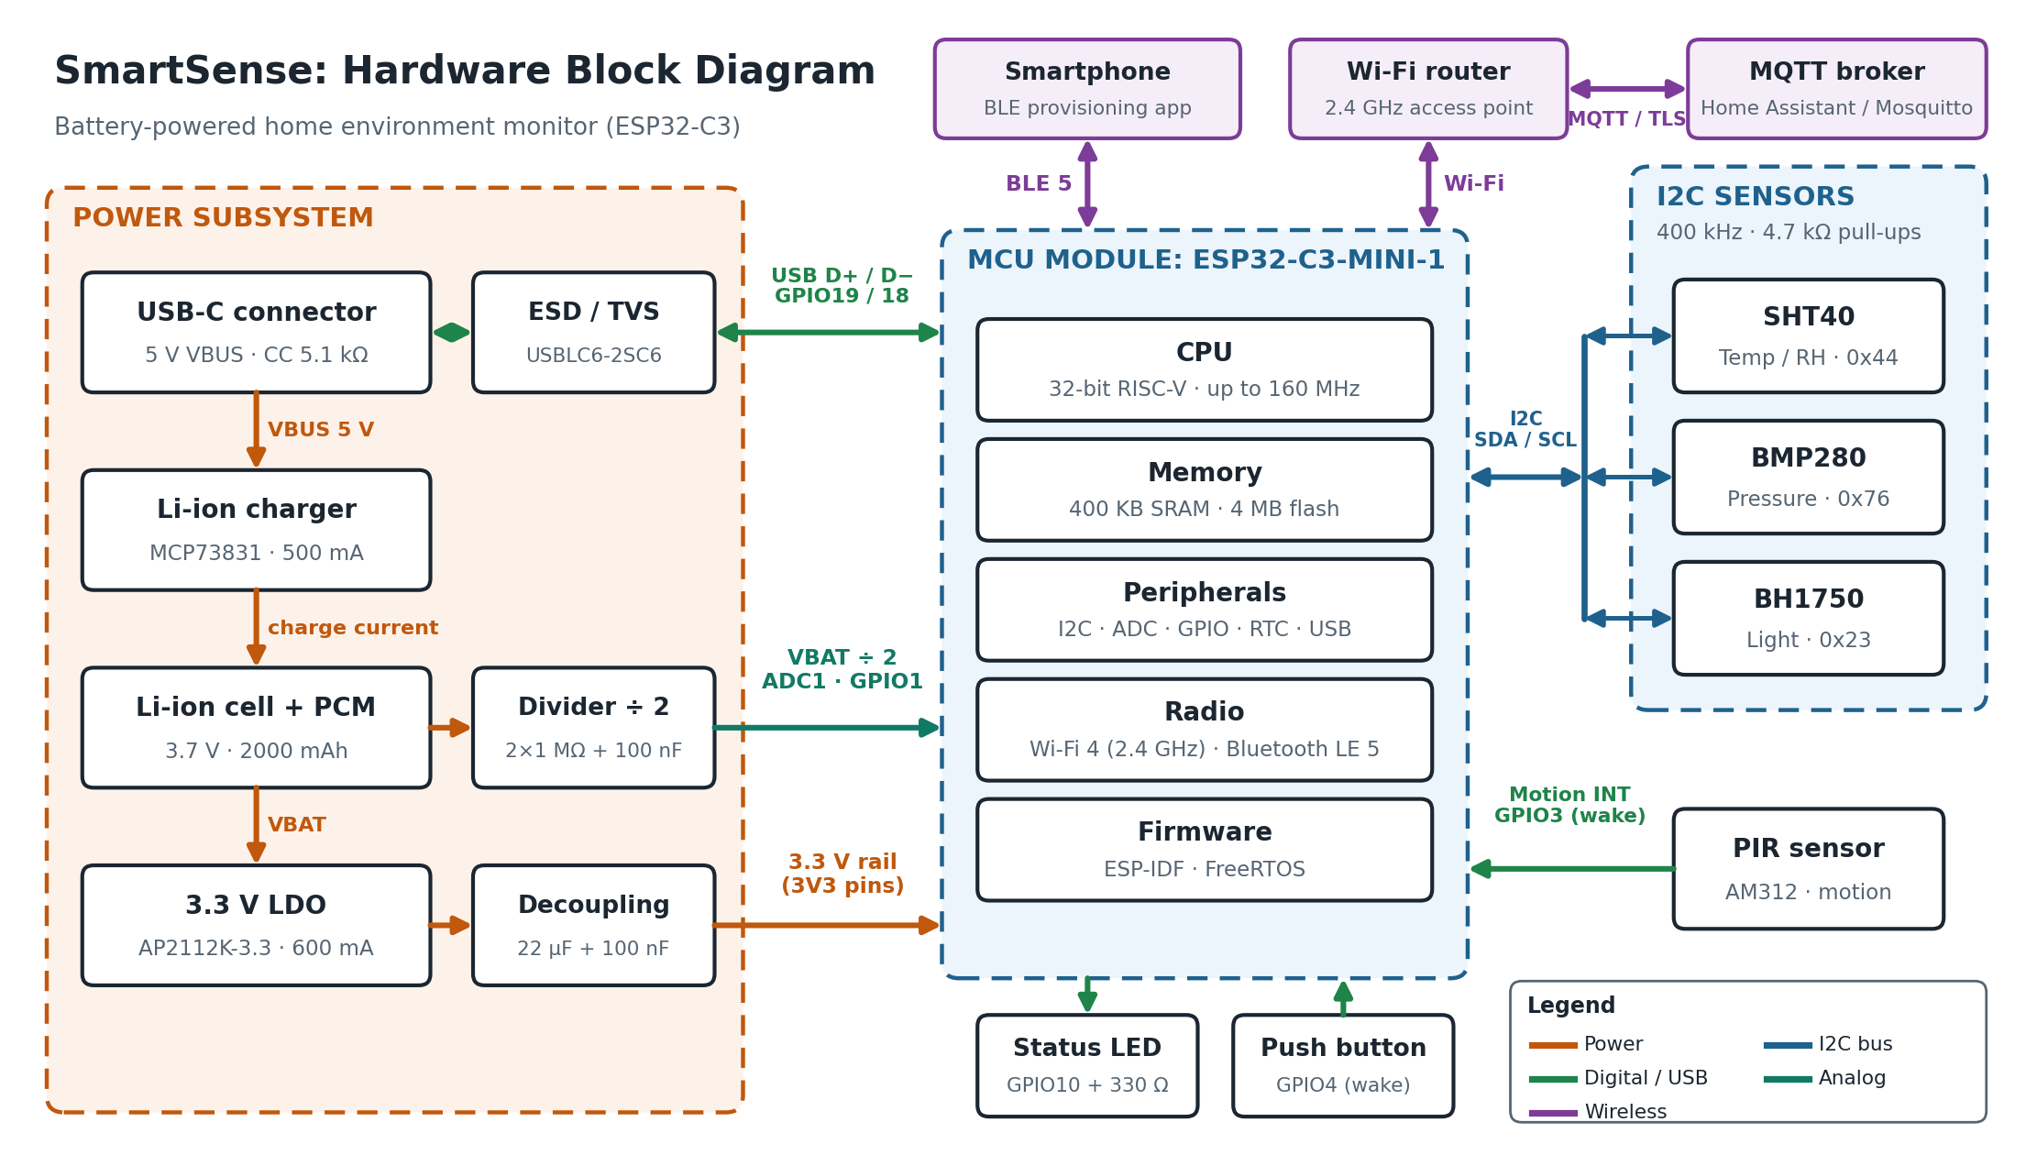
Figure 1: SmartSense hardware block diagram showing power, I2C, digital, analog and wireless connections.

4.3 Signal and power flow
The diagram can be read as four independent flows:
- Power flow. USB-C delivers 5 V VBUS to the MCP73831 charger, which charges the protected Li-ion cell at up to 500 mA. The cell (3.0 V to 4.2 V) feeds the AP2112K-3.3 low-dropout regulator, which supplies the 3.3 V rail to the module, sensors and PIR. Local decoupling (22 µF and 100 nF) absorbs the radio current bursts.
- Measurement flow. The three I2C sensors share SDA and SCL. The MCU triggers all conversions together and then reads the results, so total acquisition time is set by the slowest sensor (BH1750). The PIR output is a simple digital level that drives an RTC-capable GPIO and can wake the chip from deep sleep.
- Battery monitoring. A 2 × 1 MΩ divider scales the cell voltage (maximum 4.2 V) to 2.1 V for ADC1 on GPIO1. A 100 nF capacitor lowers the source impedance seen by the ADC, and the divider draws only about 2 µA.
- Wireless flow. Telemetry leaves the module over Wi-Fi to the home router and then to the MQTT broker, which feeds the dashboard and automations. Bluetooth LE is used only for provisioning from a smartphone. USB carries firmware, logs and charging power.
A typical cycle therefore reads: timer wake, power up the sensors, trigger conversions, read and validate the data, measure the battery, connect to Wi-Fi, publish over MQTT, confirm delivery and return to deep sleep (Figure 3).

4.4 Component selection and justification

4.4.1 Microcontroller module
Four candidate platforms were compared with a weighted decision matrix. Scores run from 1 (poor) to 5 (excellent) and reflect the needs of this project based on datasheet information; they are engineering judgements, not benchmark results.
Table 4.1: Weighted decision matrix for the microcontroller
Criterion (weight) | ESP32-C3-MINI-1 | ESP32-S3-MINI-1 | nRF52840 module | STM32L4 + Wi-Fi module
Integrated Wi-Fi and BLE (25) | 5 | 5 | 2 (BLE only) | 3
Deep-sleep power (20) | 4 | 4 | 5 | 5
Toolchain and ecosystem (15) | 5 | 5 | 4 | 4
Cost (15) | 5 | 4 | 3 | 2
Peripherals: I2C, ADC, USB (10) | 4 | 5 | 5 | 5
Certified module and size (15) | 5 | 5 | 4 | 3
Weighted score (out of 100) | 94 | 93 | 73 | 72
The ESP32-C3-MINI-1 [2] is selected. It integrates a 32-bit RISC-V core running at up to 160 MHz, 400 KB of SRAM, 4 MB of flash, 2.4 GHz Wi-Fi, Bluetooth 5 LE, a 12-bit ADC and a USB Serial/JTAG controller in a 13.2 × 16.6 mm certified module, with a deep-sleep current of about 5 µA at chip level [1]. The ESP32-S3 scores almost the same but adds a second core and resources that this application does not need at higher cost. The nRF52840 has no Wi-Fi, which would require a hub. The STM32L4 option needs an external Wi-Fi module, which increases cost and board area.

4.4.2 Sensors
Table 4.2: Sensor selection
Function | Selected | Alternatives considered | Reason for selection
Temperature and humidity | SHT40 (Sensirion) | DHT22; BME280 | Typical accuracy ±0.2 °C and ±1.8 %RH, I2C with CRC-8, about 8 ms conversion and sub-µA standby. The DHT22 uses a slow proprietary one-wire protocol; the BME280 is cheaper per function but its self-heating and ±3 %RH humidity accuracy are weaker.
Pressure | BMP280 (Bosch) | LPS22HB; BME280 | ±1 hPa absolute accuracy, 0.1 µA in sleep, forced mode for one-shot readings, supply 1.71 V to 3.6 V.
Ambient light | BH1750 (ROHM) | VEML7700; photoresistor with ADC | Digital lux output with a spectral response close to the human eye, 1 lx to 65535 lx, power-down current about 0.01 µA, no ADC channel needed.
Motion | AM312 mini PIR | mmWave radar; ultrasonic | Draws about 15 µA continuously and gives a clean digital output for wake-up; radar modules draw tens of mA, which would destroy battery life.
I2C addresses are unique (0x44, 0x76, 0x23), so no address conflicts exist on the shared bus. All three sensors run from 3.3 V.

4.4.3 Power components
Table 4.3: Power component selection
Block | Selected part | Key data | Reason
Battery | 1S Li-ion, 2000 mAh, with PCM | 3.7 V nominal, 4.2 V full, about 3.0 V empty | High energy density, rechargeable, protected against abuse (PW-07).
Charger | MCP73831 | 4.2 V CC/CV, programmable up to 500 mA, STAT output; 2 kΩ on PROG sets 500 mA | Small SOT-23-5 part that needs few external components. Full charge takes about 4 to 5 hours.
Regulator | AP2112K-3.3 | 600 mA, dropout about 250 mV at full load, quiescent current about 55 µA | Low-noise LDO for RF, simple and cheap. A buck-boost converter would be more efficient at low battery voltage but costs more and needs a larger board.
USB protection | USBLC6-2SC6 + 5.1 kΩ CC resistors | ESD protection on D+/D−; resistors identify the node as a USB sink | Protects the module against ESD and lets any USB-C source supply 5 V.
Battery sense | 2 × 1 MΩ + 100 nF | Scales 4.2 V to 2.1 V, about 2 µA | Meets ±50 mV accuracy with ADC calibration; low leakage.

4.4.4 Communication technology
Table 4.4: Communication choices
Decision | Chosen | Alternatives | Rationale
Radio | Wi-Fi (plus BLE for set-up) | Zigbee / Thread, BLE-only, LoRa | Works with the existing router and needs no hub or gateway. The cost is higher radio energy, which is managed by duty cycling (Section 4.6).
Application protocol | MQTT 3.1.1 over TLS | HTTP REST, CoAP | Lightweight publish/subscribe with QoS levels and persistent sessions; supported natively by Home Assistant and most brokers.
Sensor bus | I2C | SPI, 1-Wire | Two wires for three devices, standard speed, low power; all chosen sensors support it.
Data format | JSON | CBOR, binary | Human-readable, easy to debug and consumed directly by dashboards; 200 bytes is acceptable.

4.5 Interface and pin design
Table 4.5: Proposed pin assignment (ESP32-C3-MINI-1)
Signal | GPIO | Direction | Notes
I2C SDA | GPIO6 | Bidirectional | 4.7 kΩ pull-up to 3.3 V
I2C SCL | GPIO7 | Output (open drain) | 4.7 kΩ pull-up to 3.3 V
Battery sense | GPIO1 (ADC1_CH1) | Analog input | 12 dB attenuation, eFuse calibration
PIR output | GPIO3 | Input | RTC-capable, wake source from deep sleep
Push button | GPIO4 | Input, active low | RTC-capable wake source; 10 kΩ external pull-up
Status LED | GPIO10 | Output | 330 Ω series resistor, about 4 mA
USB D− / D+ | GPIO18 / GPIO19 | USB | Native USB Serial/JTAG, protected by USBLC6-2SC6
Reset (EN) | EN pin | Input | RC reset network and optional reset button
The pins were chosen to avoid the ESP32-C3 strapping pins (GPIO2, GPIO8 and GPIO9), which determine boot mode. Only GPIO0 to GPIO5 can wake the chip from deep sleep, so the PIR (GPIO3) and button (GPIO4) are placed there.

I2C electrical check
For Fast-mode (400 kHz) the I2C specification [9] limits the rise time to 300 ns. With pull-up resistance Rp = 4.7 kΩ and an estimated bus capacitance Cb = 60 pF (three devices plus traces), the rise time is tr = 0.8473 × Rp × Cb = 0.8473 × 4700 Ω × 60 pF ≈ 239 ns, which meets the limit with margin. The minimum allowed pull-up for 3 mA sink current is (3.3 V − 0.4 V) / 3 mA ≈ 970 Ω, so 4.7 kΩ also keeps the low-level current small (about 0.7 mA only while a line is held low).

4.6 Power architecture and energy budget

4.6.1 Deep-sleep current budget
Table 4.6: Deep-sleep current budget
Contributor | Current (µA) | Source / note
ESP32-C3 chip in deep sleep (RTC timer and RTC memory on) | 5 | ESP32-C3 datasheet [1]
AP2112K-3.3 quiescent current | 55 | AP2112 datasheet [8]
PIR AM312 (always on) | 15 | Manufacturer typical value
Battery divider (4.2 V across 2 MΩ) | 2 | Calculated: 4.2 V / 2 MΩ ≈ 2.1 µA
SHT40, BMP280, BH1750 in sleep or power-down | 1 | Datasheets [4][5][6], combined
Margin for charger leakage, pull-ups and board leakage | 22 | Engineering allowance
Total sleep budget | 100 | Meets PW-03 (≤ 100 µA)

4.6.2 Active-phase energy
Table 4.7: Active-phase charge (estimated)
Phase | Duration (s) | Average current (mA) | Charge (mA·s)
Boot + init | 0.3 | 30 | 9
Sensor read | 0.3 | 30 | 9
Wi-Fi connect | 1.0 | 110 | 110
TLS + MQTT publish | 1.2 | 120 | 144
Shutdown | 0.2 | 30 | 6
Total active phase | 3.0 | 92.7 (average) | 278
The Wi-Fi radio can draw peaks of roughly 350 mA during transmission [1]; Table 4.7 lists time-averaged phase currents, which determine battery life. The peaks matter for regulator and decoupling design and are covered in Section 4.6.4.

4.6.3 Battery life
Average current over one reporting period T is I_avg = (Q_active + I_sleep × (T − t_active)) / T and battery life is L = C_usable / I_avg, with C_usable = 1700 mAh (85 % of 2000 mAh), Q_active = 278 mA·s, t_active = 3.0 s and I_sleep = 0.1 mA. For the default T = 300 s: I_avg = (278 + 0.1 × 297) / 300 = 1.026 mA and L = 1700 / 1.026 ≈ 1657 h ≈ 69.1 days, which exceeds PW-02 (60 days) by about 15 %.
Table 4.8: Estimated battery life for different reporting intervals
Reporting interval | Average current (mA) | Estimated battery life (days) | Comment
1 min | 4.728 | 15.0 | Too short for the 60-day goal
5 min | 1.026 | 69.1 | Default; meets PW-02
15 min | 0.409 | 173.4 | Meets PW-02
30 min | 0.254 | 278.6 | Self-discharge becomes the limit (A3)
60 min | 0.177 | 399.9 | Self-discharge becomes the limit (A3)

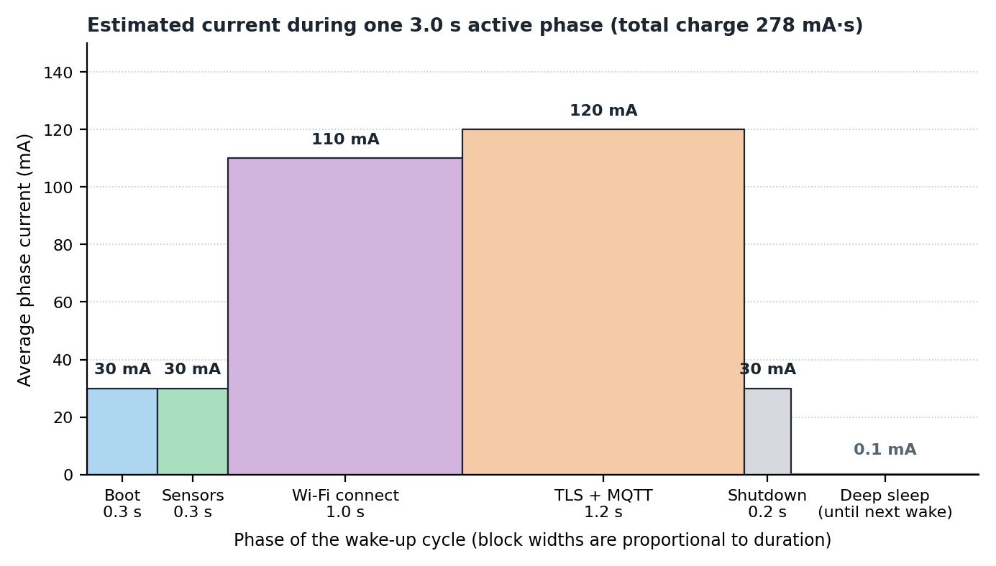
Figure 4: Estimated current during one 3.0 s active phase.
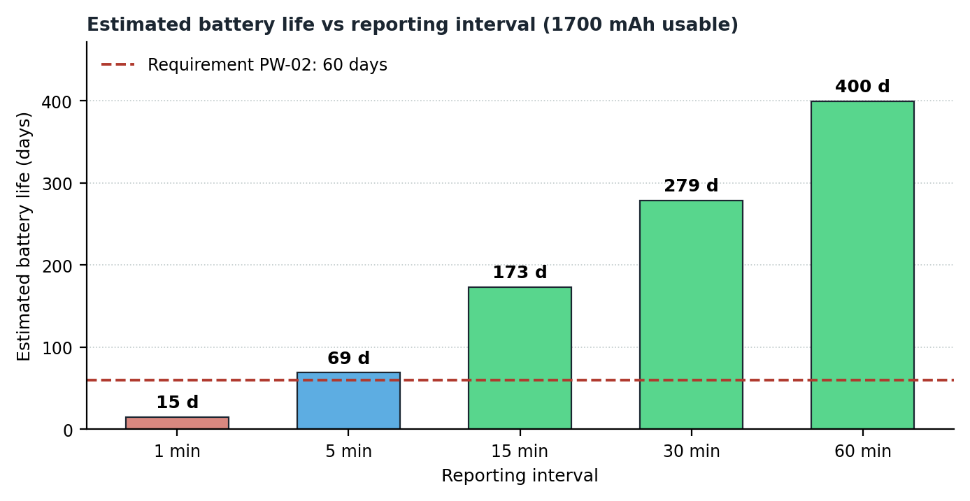
Figure 5: Estimated battery life versus reporting interval, compared with the 60-day requirement.

4.6.4 Supply headroom during radio bursts
At the shutdown threshold VBAT = 3.3 V, a 350 mA burst causes a cell voltage drop of roughly 50 mV (assuming 100 to 150 mΩ internal resistance) and an LDO dropout of about 250 mV × (350 / 600) ≈ 150 mV. The rail therefore stays near 3.1 V, above the 3.0 V minimum of the module (PW-06). This is why the firmware shuts down at 3.3 V instead of using the full cell capacity, and why 22 µF bulk plus 100 nF decoupling is placed next to the module. The linear regulator wastes (VBAT − 3.3 V) / VBAT of the energy, about 11 % at 3.7 V; this is accepted for simplicity, low RF noise and cost.

4.7 Software architecture and operating logic
The firmware follows a three-layer structure (Figure 2). The application layer contains six FreeRTOS-based modules with a single responsibility each; the middleware layer consists of standard ESP-IDF components [3]; and the driver layer isolates the hardware so that sensors or pins can change without touching application logic. The operating cycle is described by the flowchart in Figure 3. Both figures follow on the next two pages.
Table 4.9: Application modules
Module | Responsibility | Related requirements
Main controller | Handles wake cause, runs the state machine (BOOT, MEASURE, TRANSMIT, SLEEP, PROVISION, FAULT), feeds the watchdogs and enforces the 20 s cycle cap. | FR-07, RT-04, RT-05, NF-04
Sensor manager | Initialises sensors, triggers conversions together, reads results, checks CRC and range, retries three times, sets fault flags, receives PIR events from the ISR queue. | FR-01 to FR-05, FR-16, RT-01, RT-08
Power manager | Reads battery voltage (8-sample average), converts to percent with a lookup table, applies 3.5 V and 3.3 V thresholds, configures deep-sleep wake sources, manages the RTC-memory buffer. | FR-06, FR-12, FR-18, PW-03, PW-08
Connectivity manager | Fast Wi-Fi reconnect, SNTP, MQTT connect/publish/subscribe with time-outs and back-off, flushes buffered readings. | FR-08, FR-09, FR-12, FR-17, PR-06
Provisioning and UI | BLE provisioning service, button debounce and long-press detection, status LED patterns. | FR-10, FR-14, RT-06
OTA and config manager | NVS read/write of settings, HTTPS OTA with dual slots, marks new image valid or rolls back. | FR-11, FR-13, NF-02, NF-03

4.7.1 Software architecture diagram
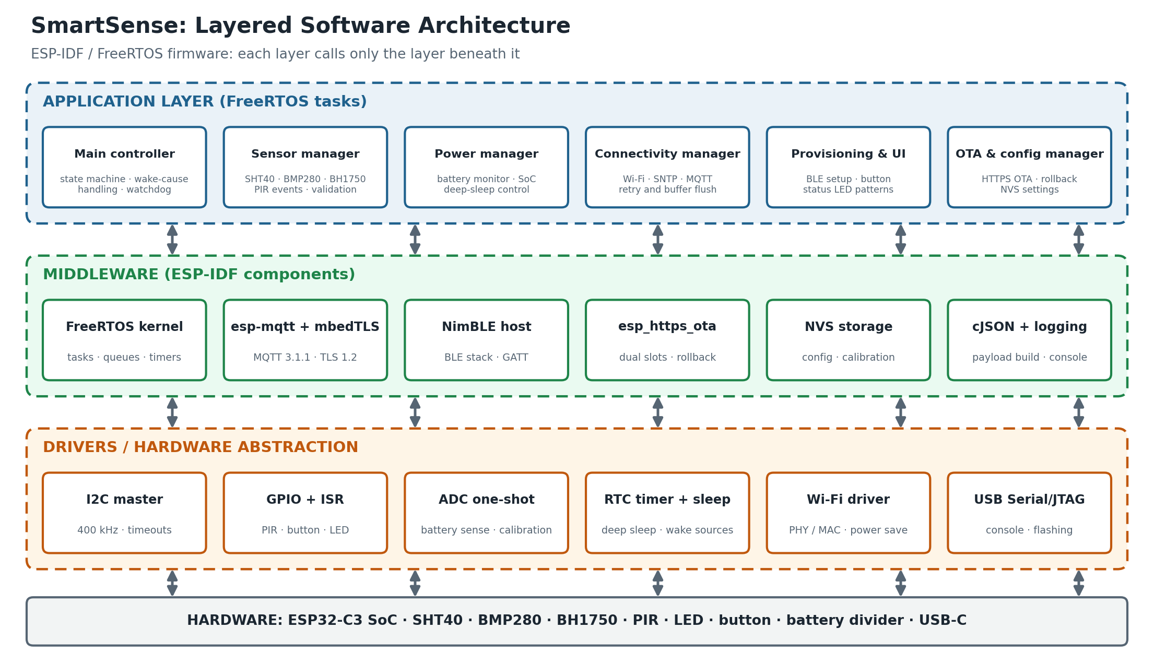
Figure 2: Layered software architecture of the SmartSense firmware.

4.7.2 Operating-cycle flowchart
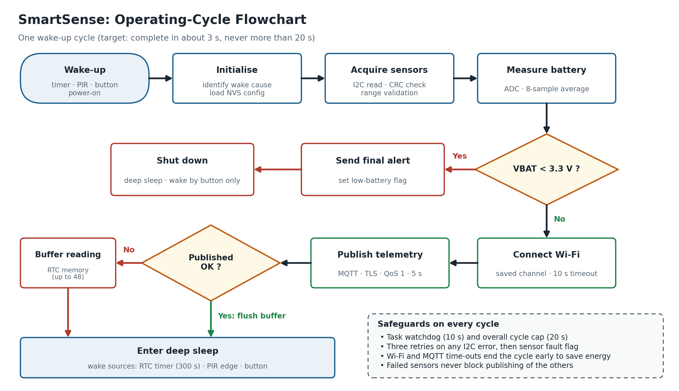
Figure 3: Operating-cycle flowchart for one wake-up, including low-battery and network-failure paths.

4.8 Operating modes
Table 4.10: Operating modes
Mode | Description | Typical current | Entry | Exit
Active | Measure and transmit, about 3 s per cycle | About 93 mA average (peaks about 350 mA) | Timer, PIR or button wake | Cycle complete or time-out
Deep sleep | CPU off; RTC timer, RTC memory and wake GPIOs on | ≤ 0.1 mA (whole board) | End of cycle | RTC timer, PIR edge, button
Provisioning | BLE advertising, LED fast blink, 5-minute limit | Tens of mA | No config or 5 s button press | Config saved or time-out
OTA update | Wi-Fi connected, image download and verification | About 100 to 120 mA | OTA command and VBAT ≥ 3.7 V | Reboot into new image
Critical-battery shutdown | Deep sleep with timer disabled | ≤ 0.1 mA | VBAT ≤ 3.3 V | Button press and VBAT ≥ 3.5 V

Table 4.11: Status LED patterns (single LED on GPIO10)
State | Pattern
Boot | One 100 ms flash
Provisioning | Fast blink, 5 Hz
Connecting to Wi-Fi or broker | One short flash per second
Error (sensor or network fault) | Three flashes, then off
Low battery | Two short flashes at the end of each cycle

4.9 Data model and storage design

4.9.1 MQTT topics
Table 4.12: MQTT topic structure (home/<room>/<device_id>/...)
Topic suffix | Direction | QoS | Content
telemetry | Publish | 1 | Periodic JSON measurement message (Table 3.7)
event/motion | Publish | 1 | Motion event with time stamp
status | Publish, retained | 1 | Firmware version, reset reason, uptime counters, battery state
cmd | Subscribe | 1 | Interval change, OTA trigger, reboot. Queued by the broker through a persistent session and delivered while the node is awake.

4.9.2 Status flag field
Bit | Meaning
0 | SHT40 fault
1 | BMP280 fault
2 | BH1750 fault
3 | Low battery (VBAT ≤ 3.5 V)
4 | Buffered (late) reading

4.9.3 Flash partition plan (4 MB)
Table 4.13: Flash partition table
Name | Offset | Size | Purpose
nvs | 0x009000 | 24 KB | Configuration, credentials, calibration
otadata | 0x00F000 | 8 KB | Active OTA slot and rollback state
phy_init | 0x011000 | 4 KB | Radio calibration data
ota_0 | 0x020000 | 1.5 MB | Application image slot A
ota_1 | 0x1A0000 | 1.5 MB | Application image slot B
coredump | 0x320000 | 64 KB | Crash dump for post-mortem debugging
storage | 0x330000 | 832 KB | Event log and spare data
The partitions end exactly at 0x400000 (4 MB). The firmware target of 1.2 MB (NF-09) fits in a 1.5 MB slot with 20 % margin. The RTC memory buffer holds 48 readings of 16 bytes each (768 bytes) out of the 8 KB of RTC memory, which covers 4 hours of outage at the default interval.

4.10 Requirements traceability matrix
Table 4.14: Traceability from requirements to design elements and verification
Requirements | Design element | Verification
FR-01 to FR-04, PR-01 to PR-05 | SHT40, BMP280, BH1750 on I2C; Sensor manager | V-01
FR-05, FR-09, RT-03, RT-08 | AM312 PIR, GPIO3 wake, ISR-to-queue design | V-08
FR-06, FR-18, PW-06, PW-08 | Battery divider, ADC1, Power manager thresholds, LDO headroom | V-04
FR-07, PR-07, RT-07 | RTC timer wake, Main controller | V-02, V-03
FR-08, PR-06, PR-08, PR-10, NF-01 | Wi-Fi, MQTT over TLS, Connectivity manager | V-03
FR-10, FR-11, NF-02 | BLE provisioning, NVS, Provisioning and UI | V-06
FR-12 | RTC-memory ring buffer (48 × 16 B) | V-07
FR-13, NF-03 | Dual OTA slots with rollback, secure boot option | V-05
FR-14, FR-15, FR-16, FR-17, FR-19 | LED patterns, diagnostics fields, fault flags, SNTP, USB console | V-09
PW-01, PW-05, PW-07 | USB-C, MCP73831, protected cell | V-10
PW-02, PW-03, PW-04 | Deep-sleep design, energy budget (Tables 4.6 to 4.8) | V-02
RT-01, RT-02, RT-04, RT-05, NF-04 | Time-outs, task watchdog, 20 s cycle cap | V-02, V-03
NF-05 to NF-09 | Enclosure, certified module, BOM and firmware size review | Inspection and analysis

4.11 Risk analysis
Table 4.15: Risk register (L = likelihood, I = impact; H/M/L)
ID | Risk | L | I | Mitigation
R1 | Radio current bursts cause brown-out resets | M | H | 22 µF + 100 nF decoupling at the module, low-ESR LDO, shutdown at 3.3 V (Section 4.6.4).
R2 | Self-heating and board heat bias the temperature reading | M | M | Place the SHT40 away from the module and charger, add thermal slots, sample once and power down, apply an offset determined in test.
R3 | Wi-Fi access point unavailable | M | M | Time-outs, back-off and RTC-memory buffer for 48 readings (FR-12).
R4 | I2C bus lock-up | L | H | Three retries, bus-clear procedure (up to 9 SCL pulses), fault flag, task watchdog.
R5 | PIR false triggers shorten battery life | M | M | 30 s rate limit, ignore events during the connect phase, sensitivity tuning.
R6 | Failed OTA update leaves the node unusable | L | H | Dual slots, rollback if the new image is not confirmed, battery ≥ 3.7 V condition.
R7 | Li-ion safety, including charging in the cold | L | H | Protected certified cell (IEC 62133-2), 500 mA charge limit, indoor use; production variant should use a charger with NTC temperature input.
R8 | RTC oscillator drift | H | L | Accepted (±5 %, RT-07); time stamps come from SNTP on each cycle.
R9 | Credential leakage | L | H | TLS with certificate validation, encrypted provisioning session, option for NVS and flash encryption (NF-03).
R10 | Part shortage | M | M | Footprint-compatible alternatives: SHT41 or BME280, other 3.3 V LDOs.

4.12 Verification plan
The verification tests below will be executed in simulation or on a prototype during Weeks 2 to 4, and form the basis of the final test report.
Table 4.16: Verification tests
ID | Test | Method | Pass criterion
V-01 | Sensor accuracy | Compare with a calibrated reference thermo-hygrometer; use saturated salt solutions (MgCl₂ about 33 %RH, NaCl about 75 %RH) for humidity points | PR-01 to PR-04
V-02 | Current profile and battery life | Measure with a current profiler or shunt and oscilloscope over several cycles; compute average current | Sleep ≤ 100 µA; Q ≤ 300 mA·s; life ≥ 60 days; wake-to-publish ≤ 5 s
V-03 | 24-hour network soak | Run at 300 s interval and count acknowledged messages; record RSSI and watchdog resets | At least 286 of 288 messages; no unrecovered lock-up
V-04 | Low-battery and brown-out | Ramp supply from 4.2 V to 3.3 V under radio bursts with a bench supply | Rail ≥ 3.0 V; warning at 3.5 V; shutdown at 3.3 V
V-05 | OTA and rollback | Update with a good image, then with a deliberately faulty image | Good image runs; faulty image rolls back
V-06 | Provisioning | Provision a blank node from a phone; power-cycle; try a wrong password | Settings persist; errors reported by LED and console
V-07 | Outage resilience | Switch off the router for 60 minutes, then restore | All 12 readings delivered in order with the late flag set
V-08 | Motion latency | Trigger the PIR 20 times at varied intervals | Latency ≤ 5 s; at most one event per 30 s
V-09 | Interface and diagnostics demonstration | Observe LED patterns, console log, diagnostic fields and fault flags | Behaviour matches Tables 4.11 and 3.5
V-10 | Charging | Charge from 3.3 V to full at 500 mA | Complete within 6 h; termination at 4.20 V ± 1 %

5. Conclusions
This report defined the requirements and designed the architecture of SmartSense, a battery-powered smart home environment monitor. The result is a specification of 54 numbered, testable requirements; a hardware block diagram and a layered software architecture; documented trade-offs for the microcontroller, sensors, power components and communication technologies; and feasibility calculations covering energy, I2C timing and supply headroom.
Table 5.1: How the objectives were met
Objective | How it was met | Where
Clear, testable requirements | 54 numbered requirements with priority and verification method | Section 3
Complete block diagrams | Hardware block diagram, software layers and operating-cycle flowchart | Figures 1 to 3
Justified component choices | Weighted decision matrix and rationale tables for sensors, power and communication | Section 4.4
Proven feasibility | Sleep budget, active energy, battery life of 69.1 days (goal 60), I2C rise time 239 ns (limit 300 ns), rail headroom | Sections 4.5 and 4.6
Traceability and verification | Traceability matrix, risk register and ten verification tests | Sections 4.10 to 4.12

5.1 Limitations
- The device is hypothetical. Active-phase currents, bus capacitance and enclosure effects are estimates and must be confirmed by measurement.
- Battery-life estimates exclude self-discharge, battery ageing and cold-temperature capacity loss.
- Weighted scores in the decision matrix are engineering judgements based on datasheets.

5.2 Next steps
- Week 2: implement firmware modules in C (sensor sampling, timer-interrupt scheduler, status LED, UART console) following Sections 4.7 and 4.9, and simulate hardware where needed.
- Week 3: debug and optimise against the budgets in Section 4.6 and the timing limits in Table 3.9.
- Week 4: integrate the modules and run tests V-01 to V-10 as the final test report.

References
[1] Espressif Systems, ESP32-C3 Series Datasheet.
[2] Espressif Systems, ESP32-C3-MINI-1 and ESP32-C3-MINI-1U Datasheet.
[3] Espressif Systems, ESP-IDF Programming Guide (sleep modes, OTA updates, provisioning, NVS, partition tables).
[4] Sensirion AG, SHT4x Datasheet: Digital Humidity and Temperature Sensor (SHT40).
[5] Bosch Sensortec, BMP280 Digital Pressure Sensor Datasheet.
[6] ROHM Semiconductor, BH1750FVI Digital 16-bit Serial Output Type Ambient Light Sensor IC Datasheet.
[7] Microchip Technology, MCP73831/2 Miniature Single-Cell, Fully Integrated Li-Ion/Li-Polymer Charge Management Controllers Datasheet.
[8] Diodes Incorporated, AP2112 600 mA CMOS LDO Regulator Datasheet.
[9] NXP Semiconductors, UM10204: I2C-bus specification and user manual.
[10] OASIS Standard, MQTT Version 3.1.1, 2014.
[11] ISO/IEC/IEEE 29148:2018, Systems and software engineering: Life cycle processes: Requirements engineering.
[12] IEC 62133-2, Safety requirements for portable sealed secondary lithium cells and batteries for use in portable applications.
[13] IETF RFC 4330, Simple Network Time Protocol (SNTP) Version 4.

Appendix A: Indicative bill of materials
Ref | Part | Function | Key specification
U1 | ESP32-C3-MINI-1 (4 MB flash) | MCU and radio | RISC-V 160 MHz, Wi-Fi 4, BLE 5, certified module
U2 | SHT40 | Temperature and humidity | ±0.2 °C, ±1.8 %RH typ., I2C 0x44
U3 | BMP280 | Pressure | ±1 hPa typ., I2C 0x76
U4 | BH1750FVI | Ambient light | 1 to 65535 lx, I2C 0x23
U5 | AM312 | PIR motion sensor | About 15 µA, digital output
U6 | MCP73831 | Li-ion charger | 4.2 V, 500 mA with 2 kΩ PROG
U7 | AP2112K-3.3 | 3.3 V LDO | 600 mA, Iq about 55 µA
U8 | USBLC6-2SC6 | USB ESD protection | Low-capacitance TVS array
BT1 | 1S Li-ion 2000 mAh with PCM | Battery | 3.7 V nominal, IEC 62133-2 compliant
J1 | USB-C receptacle (with 2 × 5.1 kΩ on CC) | Power and programming | USB 2.0
R, C | Pull-ups, divider, LED resistor, decoupling | Passive components | 4.7 kΩ ×2, 1 MΩ ×2, 330 Ω, 2 kΩ, 22 µF, 100 nF
D1, SW1 | Status LED, tactile switch | User interface | GPIO10, GPIO4

Appendix B: Glossary
Term | Meaning
ADC | Analog-to-digital converter
BLE | Bluetooth Low Energy
BOM | Bill of materials
CC/CV | Constant current / constant voltage (charging profile)
GPIO | General-purpose input/output
I2C | Inter-integrated circuit serial bus
LDO | Low-dropout linear regulator
MQTT | Message Queuing Telemetry Transport
NVS | Non-volatile storage
OTA | Over-the-air (firmware update)
PCM | Protection circuit module (battery)
PIR | Passive infrared (motion sensor)
RSSI | Received signal strength indicator
RTC | Real-time clock and low-power domain
SNTP | Simple Network Time Protocol
TLS | Transport Layer Security

